SIMATS ENGINEERING
CO3- ASSESSMENT TOOL 3
ERROR ANALYSIS TASK
COURSE NAME: DIGITAL SIGNAL PROCESSING COURSE CODE: ECA09
NAME: Saravana Yogesh M
REGNO:192412273
COURSE OUTCOME COVERED
CO 3: Evaluate finite word-length effects and multirate signal processing techniques, including decimation, interpolation, and polyphase decomposition.Bloom Level mapped- BL3,BL4,BL5
Topics Covered:
Quantization- Truncation and Rounding errors - Quantization noise - Limit cycle oscillations – Signal scaling.Parametric and Non parametric Spectral estimation. Decimation-Interpolation-Sampling rate conversion-Implementation of sampling rate conversion-Polyohase Decomposition -5G Decimation/Interpolation: For mmWave beamforming
Assessment Tool number | : CO3-AT23
Assessment Tool Weightage | : 40%
Assessment Tool Name | : Error Analysis Task
Duration of this assessment | : 60 Minutes
Marks | : 25 Marks
Type of Assessment Conduction | : Hybrid
- A rational sampling rate conversion algorithm applies interpolation after decimation. Using an input sampled at 24 kHz with L = 2 and M = 3, analyze why aliasing occurs and propose the correct processing order. (10) (BL5) (WK4)

Code of Conduct:

I Saravana Yogesh M, 192412273 (Name / Reg No) certify that this submission is my original work and that I have adhered to the guidelines specified for this assessment.
I understand that any violation of academic integrity rules will result in disciplinary action.
Signature of the student:
RUBRICS FOR CALCULATION:
Criteria | Weightage | Level 4 (Exemplary) | Level 3  (Proficient) | Level 2  (Developing) | Level 1  (Beginning)
Error Identification | 20% | Accurately identifies all errors with clear understanding | Identifies most errors with minor omissions | Identifies limited errors with some missed | Fails to identify key errors
Root Cause Analysis | 30% | Clearly explains underlying causes with strong reasoning | Explains causes with moderate clarity | Provides partial explanation with weak reasoning | Unable to identify causes
Correction | 25% | Provides correct solutions with strong  justification | Provides correct corrections with some justification | Provides partially correct corrections | Provides incorrect corrections
Application of  Concepts | 15% | Applies relevant concepts effectively | Applies concepts with minor errors | Applies concepts with guidance | Unable to apply concepts
Clarity of  Presentation | 10% | Presents analysis clearly with logical structure | Presents analysis with minor clarity issues | Presents analysis with poor structure | Presents unclear analysis

SOLUTION:

MATLAB CODE:

clc;
clear;
close all;

%% Q34 - Rational Sampling Rate Conversion
% Input Sampling Rate = 24 kHz
% Interpolation Factor L = 2
% Decimation Factor M = 3

%% 1. Given Parameters

Fs_in = 24000; % Input sampling frequency
L = 2; % Interpolation factor
M = 3; % Decimation factor

Fs_out = Fs_in * L / M;

fprintf('========================================\n');
fprintf('Q34 RATIONAL SAMPLING RATE CONVERSION\n');
fprintf('========================================\n');

fprintf('Input Sampling Rate = %.2f kHz\n', Fs_in/1000);
fprintf('Interpolation Factor = %d\n', L);
fprintf('Decimation Factor = %d\n', M);
fprintf('Output Sampling Rate = %.2f kHz\n', Fs_out/1000);

%% 2. Generate Input Signal

T = 0.02;

t = 0:1/Fs_in:T-1/Fs_in;

% Desired signal
f1 = 2000; % 2 kHz

% Interfering signal
f2 = 6000; % 6 kHz

x = sin(2*pi*f1*t) + 0.6*sin(2*pi*f2*t);

%% 3. INCORRECT METHOD
% Decimation first without anti-aliasing filter

Fs_dec = Fs_in / M;

x_dec = x(1:M:end);

% Interpolation by 2
x_wrong = zeros(1,length(x_dec)*L);

x_wrong(1:L:end) = x_dec;

% Simple interpolation filter
Fc_wrong = 3500;

b_wrong = fir1(80,Fc_wrong/(Fs_dec*L/2));

x_wrong = filter(b_wrong,1,x_wrong);

Fs_wrong = Fs_dec * L;

%% 4. CORRECT METHOD
% Interpolation first followed by decimation

% Upsampling by 2

x_up = zeros(1,length(x)*L);

x_up(1:L:end) = x;

Fs_up = Fs_in * L;

% Low-pass filter

Fc = 7000;

b = fir1(100,Fc/(Fs_up/2));

x_filtered = filter(b,1,x_up);

% Downsampling by 3

x_correct = x_filtered(1:M:end);

%% 5. Display Sampling Rates

fprintf('\n----------------------------------------\n');
fprintf('SAMPLING RATE CALCULATION\n');
fprintf('----------------------------------------\n');

fprintf('24 kHz x 2 = %.2f kHz\n',Fs_up/1000);
fprintf('48 kHz / 3 = %.2f kHz\n',Fs_out/1000);

%% 6. Aliasing Calculation

Nyquist_dec = Fs_dec/2;

alias_frequency = abs(Fs_dec - f2);

fprintf('\n----------------------------------------\n');
fprintf('ALIASING ANALYSIS\n');
fprintf('----------------------------------------\n');

fprintf('Sampling rate after decimation = %.2f kHz\n',Fs_dec/1000);

fprintf('New Nyquist frequency = %.2f kHz\n',Nyquist_dec/1000);

fprintf('Interfering frequency = %.2f kHz\n',f2/1000);

fprintf('Aliased frequency = %.2f kHz\n',alias_frequency/1000);

%% 7. Time Domain Comparison

t_wrong = (0:length(x_wrong)-1)/Fs_wrong;

t_correct = (0:length(x_correct)-1)/Fs_out;

figure;

subplot(3,1,1);

plot(t*1000,x);

xlabel('Time (ms)');
ylabel('Amplitude');

title('Original Signal - 24 kHz');

grid on;

xlim([0 5]);

subplot(3,1,2);

plot(t_wrong*1000,x_wrong);

xlabel('Time (ms)');
ylabel('Amplitude');

title('Incorrect: Decimation First');

grid on;

xlim([0 5]);

subplot(3,1,3);

plot(t_correct*1000,x_correct);

xlabel('Time (ms)');
ylabel('Amplitude');

title('Correct: Interpolation First');

grid on;

xlim([0 5]);

%% 8. Spectrum Analysis

NFFT = 4096;

X = fft(x,NFFT);

X_wrong = fft(x_wrong,NFFT);

X_correct = fft(x_correct,NFFT);

f_wrong = (0:NFFT/2-1)*Fs_wrong/NFFT;

f_correct = (0:NFFT/2-1)*Fs_out/NFFT;

figure;

plot(f_wrong/1000,...
20*log10(abs(X_wrong(1:NFFT/2))+eps));

hold on;

plot(f_correct/1000,...
20*log10(abs(X_correct(1:NFFT/2))+eps));

xlabel('Frequency (kHz)');
ylabel('Magnitude (dB)');

title('Spectrum Comparison');

legend('Incorrect Conversion','Correct Conversion');

grid on;

xlim([0 8]);

%% 9. Final Result

fprintf('\n========================================\n');
fprintf('FINAL RESULT\n');
fprintf('========================================\n');

fprintf('Required Output Sampling Rate = 16 kHz\n');

fprintf('Incorrect method causes aliasing.\n');

fprintf('6 kHz signal aliases to 2 kHz.\n');

fprintf('Correct method: Interpolation by 2 followed by Decimation by 3.\n');

fprintf('Anti-aliasing/interpolation filtering is applied.\n');

fprintf('========================================\n');

OUTPUT:

Figure 1:
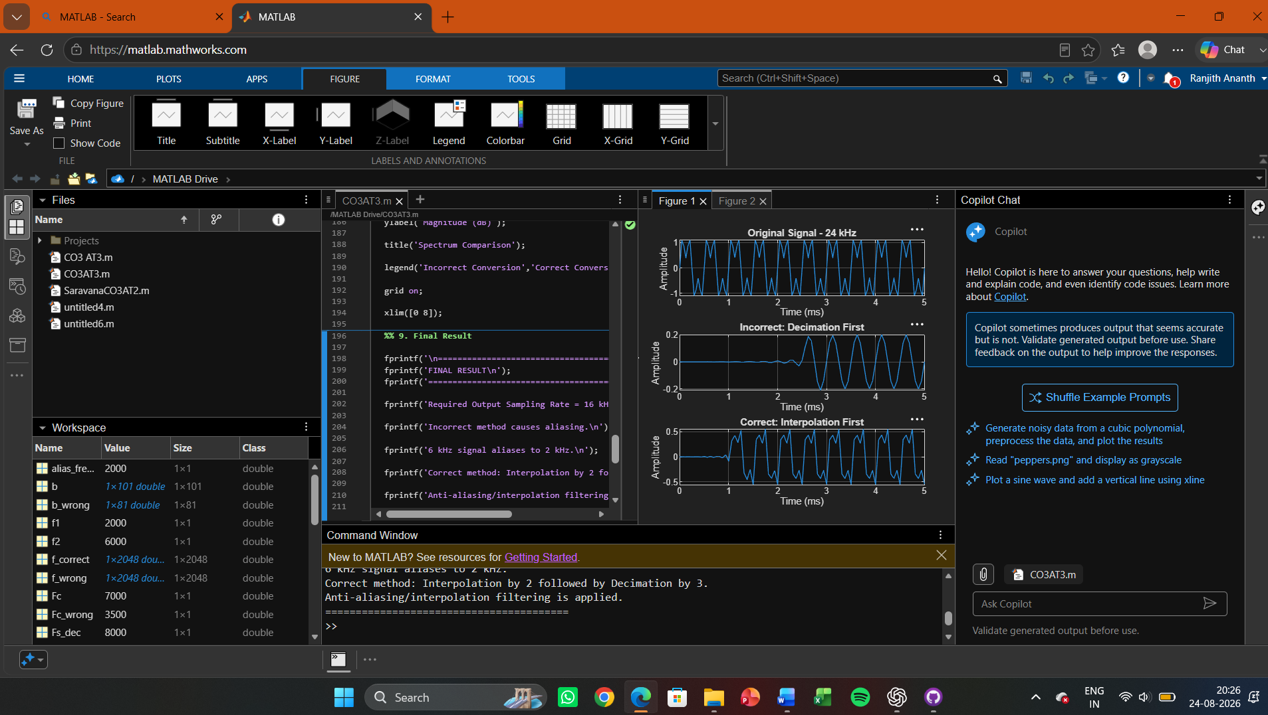
Figure 2:

